System Output Box V1-0, CG, Mar05,2010.

Overview: 19” unit that connects to the myMix network (own MAC address) and is capable of receiving up to 16 myMix network channels or submix channels and converts them individually to balanced line level outputs. This allows all signals that are directly feed into the individual myMix units to be available for other use (e.g. FOH console).
Sketch:
Front view

Rear View
Specs:
19”, 1U metal housing
Balanced XLR outputs, line level (max. output level +21dBu), audio specs as myMix.
External power supply or internal power supply 100V to 240V 50/60Hz
Integrated network switch (100MBps)
Approvals: CE, FCC, UL,
Cost Target: 19” housing + psu ($17) + pcb board ($60)+ ($3) = $80 * 1,2 = $96 total mfg cost max.
Annual quantity: conservative estimate 1000 units (up to 10% of annual myMix sales)
Schedule:
Launch at Infocomm June 2010 with 2 working prototypes (engineering samples)
Prototypes: 5 engineering samples: 2 MOVEK, 2 Lab-X, 1 Vtech.
Production Start: Pilot (25) July, 1st Series (100) September, 2nd series (400) October 2010.
Alternative Version:
Front panel display with encoder for assignment, Channel Signal Present and Clip LED.

For the output units there will be a new menu point: OUTPUTS
The network shall be able to accept at least 8 output boxes.
Naming an output box shall be possible when connected directly to one myMix (and nothing else) via the Output menu. The box shows up (no other devices on the network allowed in that mode) and can then be selected and named.
Selecting the OUTPUTS menu on a unit in the network shows a list of all active output devices on the network (default name: OUTPUT DEFAULT), selecting and pressing the output box opens the OUTPUT ASSIGN PAGE.
Sketch of a possible implementation:
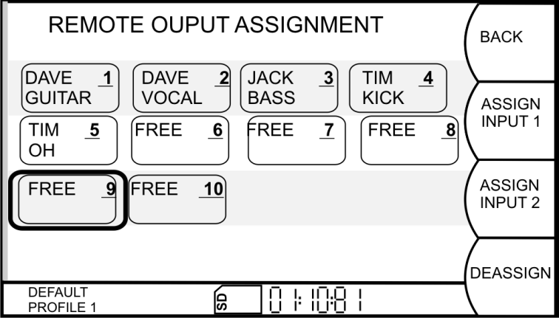
An alternative could be to allow the full assignment from every unit on the network. The Display would show all available units/channel names, select+press would open the scroll bar to select the desired output channel. (In that case the list needs to be permanently updated and only show free channels… might get tricky).

Already assigned outputs show the unit and channel name, they can’t be selected.
Selecting a free output channel then allows to assign either Input 1 or input 2 of the unit that is used for the assignment. The output assignment shall be part of a profile. In the event that two units are connecting to the network with the same assignment on the same output box, the assignment shall be cancelled and the user prompted: “output channel double assigned, please assign new”.
The “tbd Remote Software” for myMix shall be able to make these assignments directly from a central point.

